Giant Predatory Ichthyosaur Discovered in Nevada
- BY NADIA DRAKE

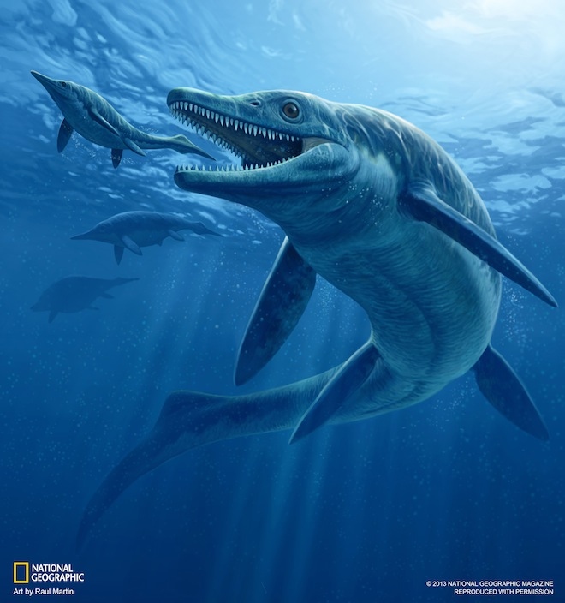
An enormous marine predator lurked in the Triassic seas covering Nevada: a 30-foot-long sea monster big enough to eat reptiles its own size.
Named Thalattoarchon saurophagis — lizard-eating sovereign of the sea — the four-finned icthyosaur was a large apex marine predator, occupying the same position atop its food web as present-day great white sharks and killer whales, a team of paleontologists reports Jan. 7 in Proceedings of the National Academy of Sciences.
“It was the first giant air-breathing marine predator equipped with teeth with cutting edges,” saidRyosuke Motani, a paleobiologist at the University of California, Davis who was not involved in the discovery.
T. saurophagis had a mouth full of 5-inch-long teeth and existed just 8 million years after a mass extinction killed most of the planet’s marine fauna at the end of the Permian period, 252 million years ago. That such a large predator emerged so soon after a catastrophic resetting of life on Earth suggests marine ecosystems might have rebounded more quickly than terrestrial ecosystems, the team reports.
Pulled from a remote mountain range that’s part of the Favret Formation in central Nevada, the beast’s 244-million-year-old fossil is now housed in The Field Museum in Chicago. Paleontologists unearthed the mega-reptile’s partially complete fossil in 2008, though it was first spotted in 1997.
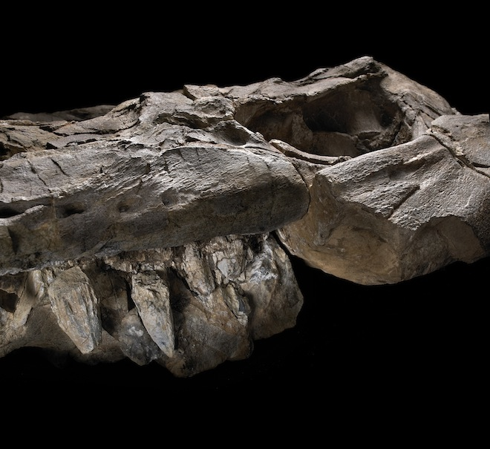
A jaw full of five-inch teeth helped Thalattoarchon saurophagis tear into prey. (John Weinstein, The Field Museum, Chicago)
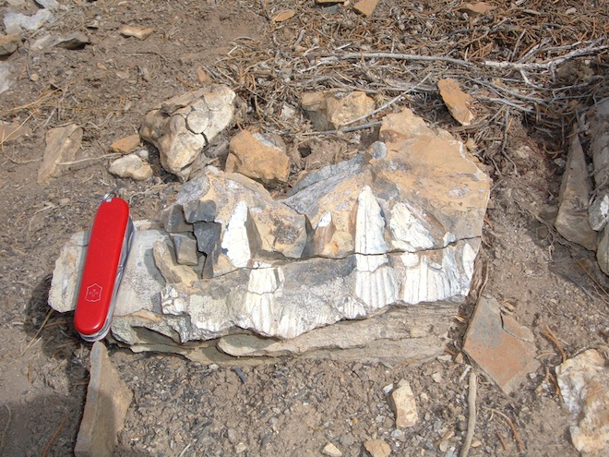
The jaws of Thalattoarchon in the field. (Nicole Klein, Universität Bonn, Germany)

