Activity Sheet Name ________________
Chapter 6, Lesson 12
Natural Resources & Synthetic Materials Period_________________
Background Information: In science, a “synthetic” material is when the starting substances are changed chemically to produce a material with different characteristics. A common example is plastic. To make it, petroleum is processed and chemically changed to eventually become plastic. The series of chemical reactions that are used to change natural resources into synthetic products is called chemical synthesis.
To make a “natural” product, the natural resource is not chemically changed as much as a synthetic product. One example is a wooden chair. It is more natural than synthetic, because its shape has been changed, but the material is still wood. Glass is a little harder to classify, but could be considered a natural material. It comes from sand, which has been melted and then cooled. The molecules that make up the glass are still the same as they were in sand.
1. Both natural products and synthetic products come from natural resources. Explain why this statement is true.

2. What does it mean if a product is “synthetic”?

3. Some synthetic substances are exactly the same as substances found in nature. Why would scientists synthesize something that already exists?
(HINT: You Tube Video, “Professor Dave Explains: Will Synthetic Vitamins Make Me Explode?”)
4. Which synthetic product will you do research on? (See choice list OR choose your own)

Before starting your research, you will conduct a hands-on activity where you create a synthetic product—a gel worm. The three questions above will guide the activity and will model how to approach your research.

WHAT NATURAL RESOURCES ARE USED TO MAKE THE SYNTHETIC PRODUCT?
- The reactants in the chemical synthesis you will do are sodium alginate and calcium chloride.
Natural resources used to make the gel worm
 | Sodium Alginate | Calcium Chloride
What natural resource is this chemical made from? | A brown seaweed called kelp | Calcium chloride is made from limestone which is a common rock that is mined.
How is the natural resource processed to make this chemical? | The seaweed is cut up, mixed with water and filtered. The  water evaporates off and the sodium alginate powder is left | The limestone is reacted with hydrochloric acid or sodium chloride to make calcium chloride.
Question to investigate
Why is a gel worm made from calcium chloride and sodium alginate solutions considered a synthetic product?
Materials
- Calcium chloride solution in a small wide cup
- Sodium alginate solution in a small wide cup
- One dropper
- Paper towel
- Safety Goggles
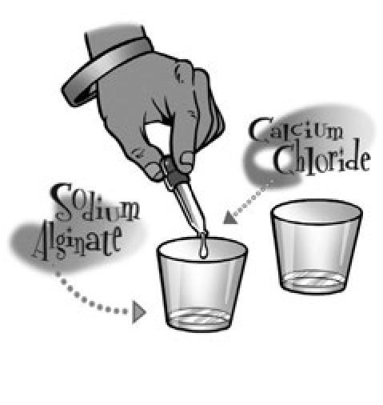
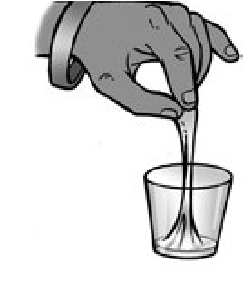
Procedure
- Use a plastic dropper to add about 10 drops of calcium chloride solution to the center of a cup containing 15 mL of sodium alginate solution.
- Reach into the center of the solution (where you put the calcium chloride) and gently and slowly pull out the gel “worm.”
- Set the “worm” on a paper towel.
4. What were the calcium chloride and sodium alginate solutions like before you added the calcium chloride solution to the sodium alginate solution?

5. After you added the calcium chloride solution to the sodium alginate solution and began pulling from the center, how did the solutions change?

- Why is the gel worm considered to be a synthetic product?
7. Label the diagram using teacher example.
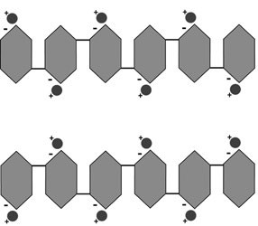 → 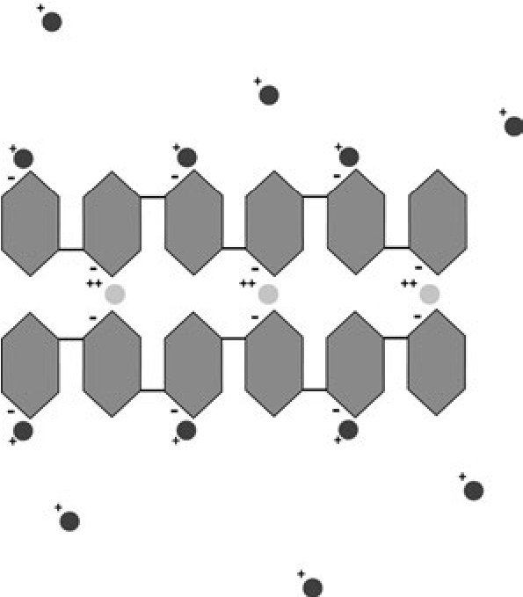

8. Describe what the calcium ions from the calcium chloride do to help make the sodium alginate polymer become a gel.

9. Are the natural resources used to make the synthetic gel worm renewable or nonrenewable? Fill out the chart to answer the question.
 | Renewable and Nonrenewable Natural Resources Used to Make Each Snack
 | Main ingredients | Natural resources used to make each | Renewable? Why or why not?
Gel worm | Sodium alginate
 | Calcium chloride
Fresh fruit slices | Fruit

10. If gel worms were made and sold on a large scale as a synthetic snack item for kids, what are some of the impacts to society of producing and using them compared to producing and using fresh fruit slices? Fill out the chart below to answer the question.
Impacts to society and the environment
 | Synthetic gel worm | Fresh fruit slices
Impact of harvesting, mining, or collecting the natural resources
Processing the natural resources to make the final product?
Usefulness of the product?

11.Which do you think is better for the environment, the gel worm snack or fresh fruit slices? Why?

12. What are the impacts to society of making and using the synthetic product, compared to making a more natural product with a similar function?

Synthetic Material Research Project
Objective: Each student will research a different synthetic product and design a poster to advertise the product. The projects should address the following questions, and include a conclusion. Use at least 3 different sources (see www.mrsmcevoy.weebly.com) , and get bonus points for recording sources. Take notes on this paper and attach lined paper if needed. Posters will be presented to the class for credit.
- What natural resources are used to make the synthetic product?

- What chemical processes are used to make the synthetic product? Include a diagram.

- What are the negative and positive impacts to society of making and using the synthetic product, compared to making and using a more natural product with a similar function?

- Conclusion: Use the results of your research to conclude which product would be the best choice for society.

Sources Used:
 | 4 | 3 | 2 | 1 | 0
What natural resources are used to make the synthetic product? | Question answered in detail, all natural resources used for the product covered and explained in detail. | Question mostly answered, most natural resources used are included. | 1-2 natural resources used are included. | 1 natural resource used briefly mentioned. | Missing
What chemical processes are used to make the synthetic product? | Chemical processes are described in detail. Includes diagram. | Chemical process is mostly described. Does not include diagram. | Chemical process is mentioned but missing important details. | Chemical process briefly mentioned. | Missing
What are the negative and positive impacts to society of making and using the synthetic product.. | Both negative and positive impacts to society described, and compared with using more natural product. | Both negative and positive included, missing comparison to more natural product. | Includes either negative or positive impacts, missing one. | Mentions impacts but missing important details. | Missing
Conclusion: Use the results of your research to conclude which product would be the best choice for society. | Includes detailed conclusion with evidence from research. | Includes conclusion with some evidence from research. | Includes conclusion but missing evidence from research. | Unclear conclusion. | Missing
Bonus: Sources cited | 3 or more sources cited | 2 sources cited | 1 source cited
Overall | Colorful, neat detailed and includes diagrams/pictures | Neat and detailed but missing color and/or diagrams/pictures | Includes some information but missing requirements. | Missing information, too messy to read.
Presentation | Clear presentation voice that covers all questions. | Most information covered, and clear presentation. | Missing information, or improvement in presentation voice. | Unclear presentation

